Project Structure> Artifacts > + >select From modules… option

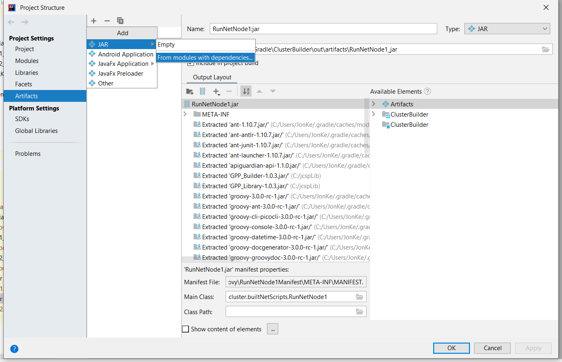

This screen appears

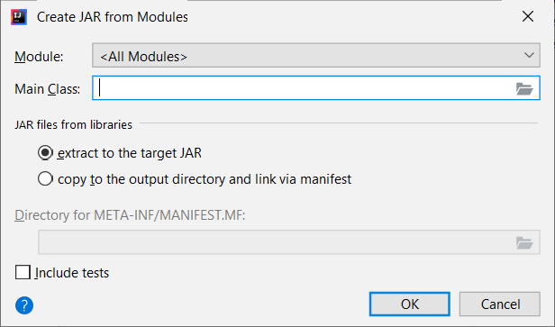

Browse in Main Class box to reveal a list of entry points

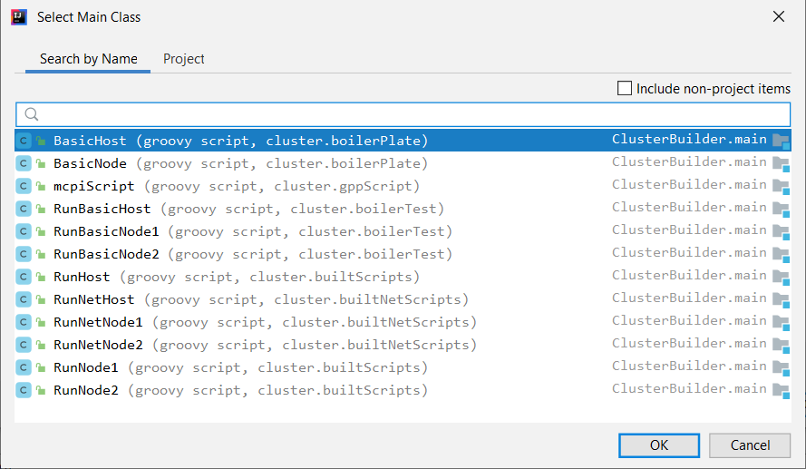

I will choose RunNetNode1, click OK

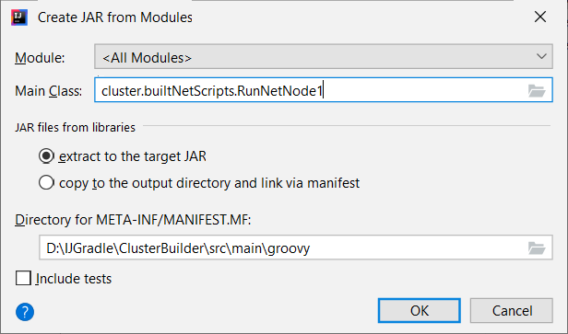

The next crucial thing is to create a unique folder in which to store the manifest! The folder will be created automatically for you

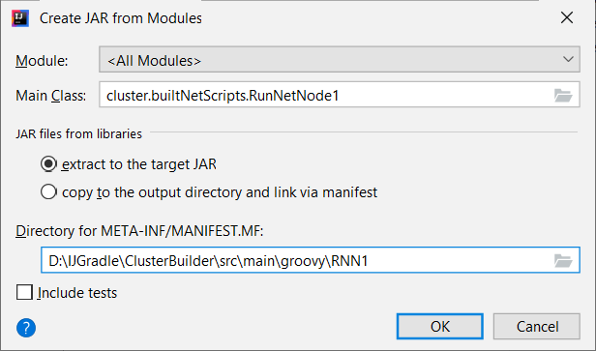

The Artifact screen becomes the following

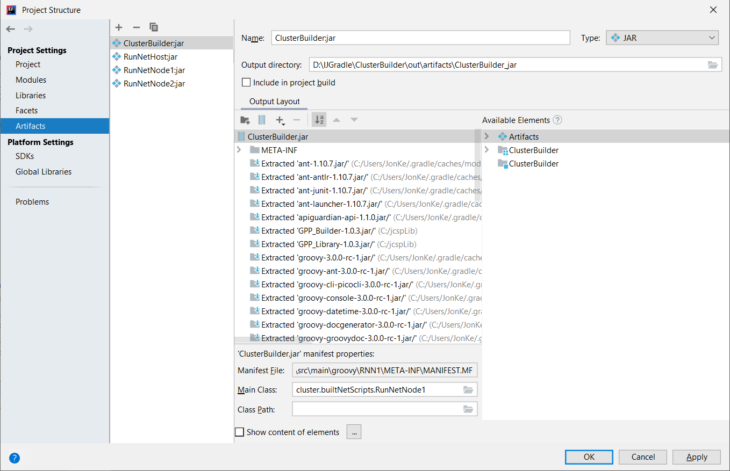

We have to make several changes because by default Intellij calls the jar file the name of the project, which in this case is ClusterBuilder.

In the Name field type a different name eg RNN1 over ClusterBuilder , which changes other things at the same time BUT NOT the name of the jar for some bizarre reason! This is the name you have to change as well in the Output Layout section. You also need to tick the Include in Project Build box.

You can also see that the name as changed in the list of Artifacts.

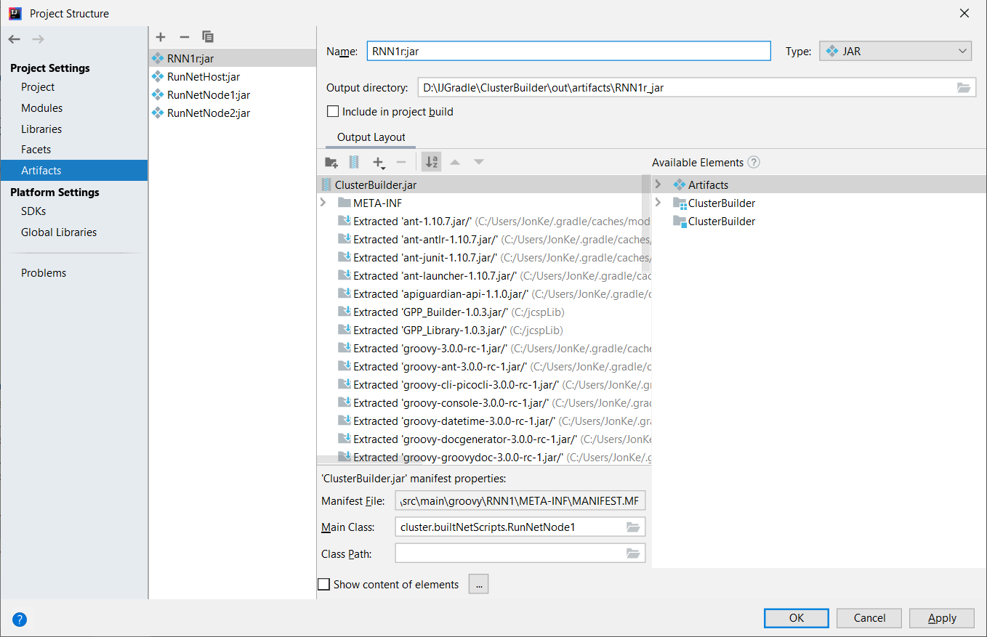

To update the name of the jar; right click on ClusterBuilder and choose Rename

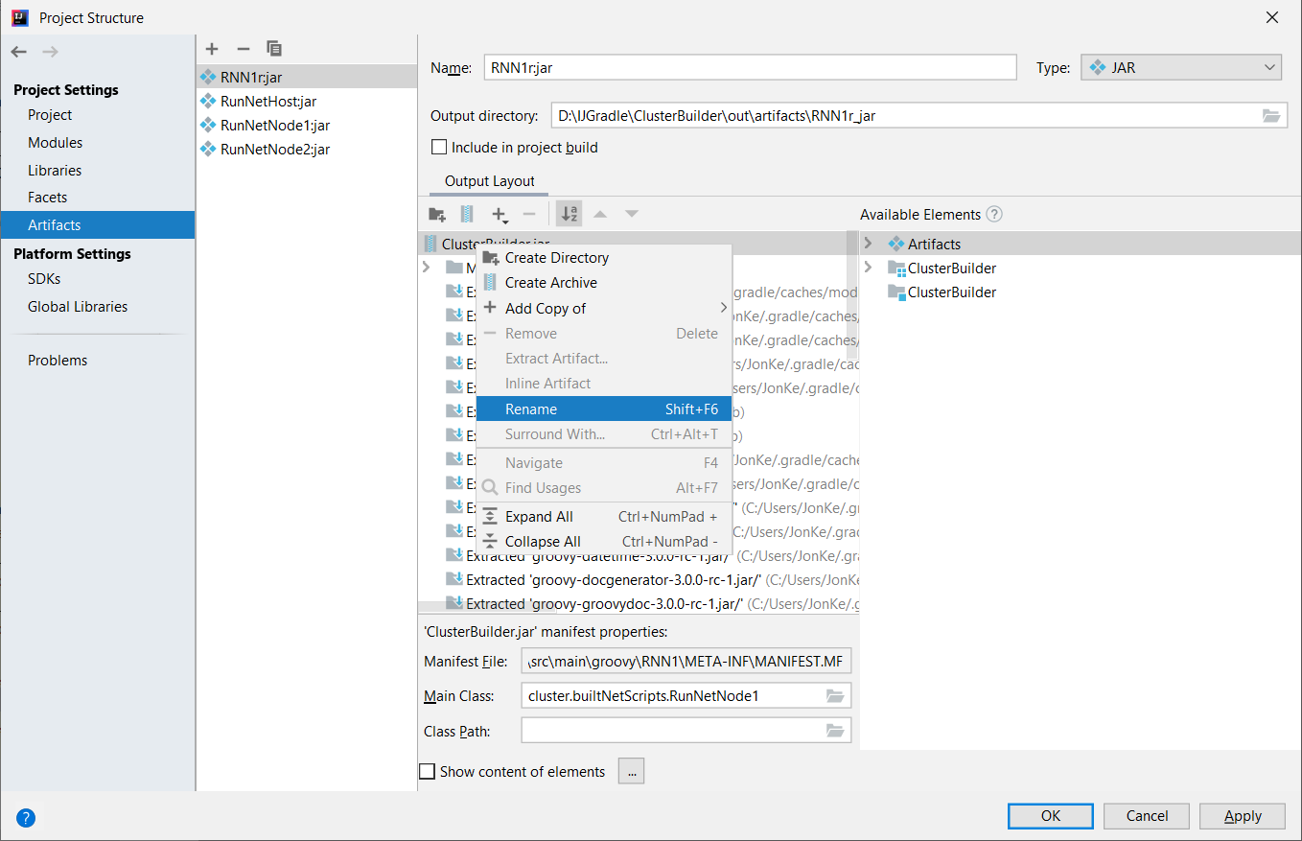

Type in the name RNN1 In this case for consistency!!

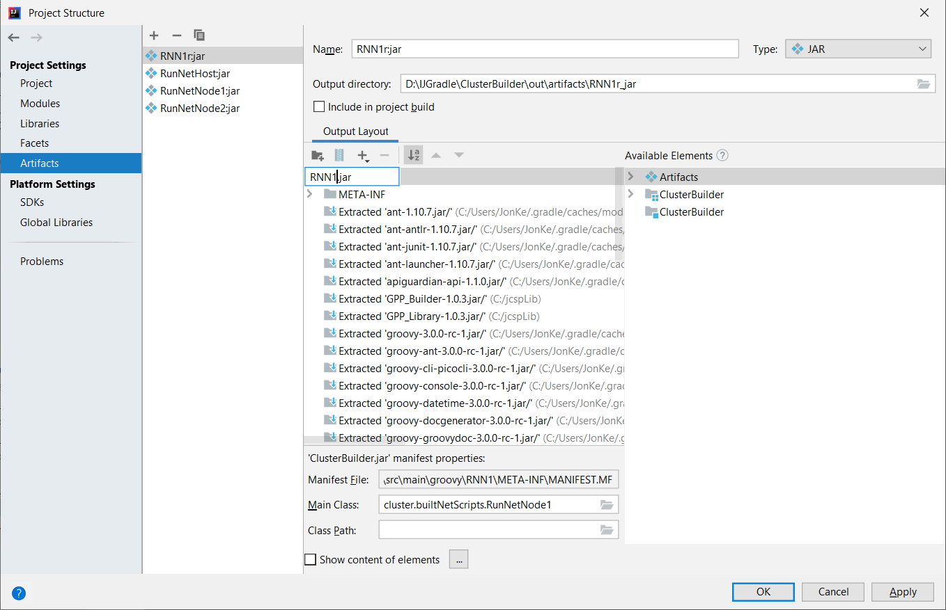

**You MUST hit enter at this point otherwise the name will not change!** You have been warned so the final screen looks like I only ticked the Include in project build box at this point not critical but you must do it!

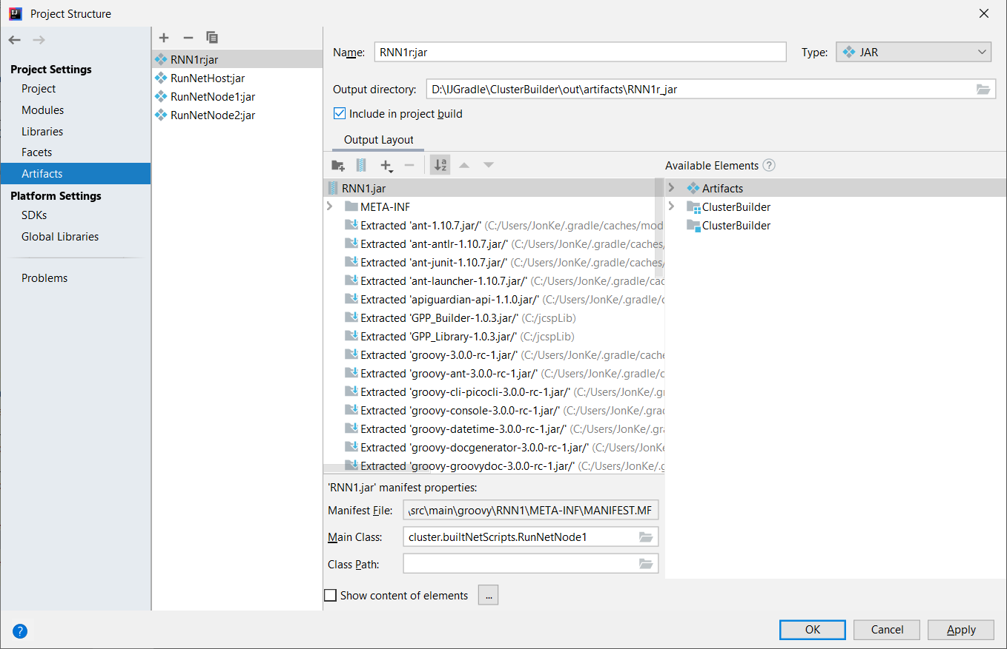

Click Apply and then OK

You now return to the main Intellij interface . Hit the build green hammer.

If you open certain folders etc you will see something like this

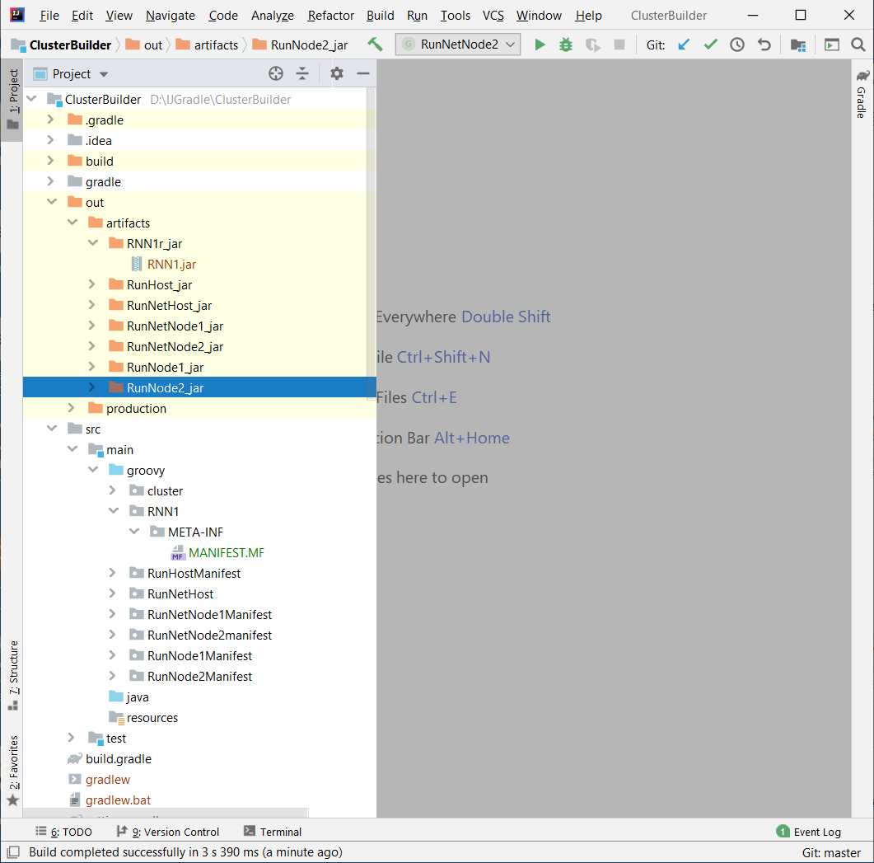

The jar file has been created in out/artifacts/RNN1_jar. The manifest is in src/main/groovy/RNN1/ The MANIFEST.MF file should contain:

**Manifest-Version**: 1.0  
**Main-Class**: cluster.builtNetScripts.RunNetNode1

This will vary for each artifact; it gives the entry point to the jar.

Hope it works for you – it would be nice to think this process could be automated!

Jon